**Department of Computer Science and Business System**

**SOFTWARE REQUIREMENT SPECIFICATION FOR**

**E -Book Reading Platform (ReadEase)**

**Team ID :** **A09**

**Team Members :**

1. **Santosh Jadhav – A59**
2. **Shlok Kadam – A56**
3. **Aman Kalaskar – A60**
4. **Aditya Hirve – A58**

**INDEX**

|  |  |  |
| --- | --- | --- |
|  |  | **Pg.no** |
| **1. INTRODUCTION** | **1.1. Purpose** | **1** |
| **1.2. Scope** | **1** |
| **1.3. Glossary** | **1** |
| **1.4. Overview** | **1** |
| **2. OVERALL DISCRIPTION** | **2.1. Problem Statement** | **2** |
| **2.2. Existing Statement** | **2** |
| **2.3. Proposed System** | **2** |
| **2.4. Product Functions** | **2** |
| **2.5. User’s Characteristics**  **2.5.1 User’s Requirement**  **2.5.2 User’s Education Level**  **2.5.3 User’s Technical Expertise** | **2-3** |
| **2.6 Constraints** | **3** |
| **3. Requirement Specification** | **3.1. Functional Requirements** | **4** |
| **3.2. Non Functional Requirement** | **4** |

**TABLE OF FIGURES:**

|  |  |  |
| --- | --- | --- |
|  |  | **Pg.no** |
| **Fig:1.1** | **Data Flow Diagram Level - 0** | **5** |
| **Fig:1.2** | **Class Diagram** | **6** |
| **Fig:1.3** | **Use case Diagram** | **7** |

## **Introduction**

In the digital age, the way we consume literature has evolved significantly. An e-book reading platform serves as a bridge between traditional reading and modern technology, offering readers unparalleled access to a vast library of texts at their fingertips. This platform not only provides a seamless reading experience but also incorporates features designed to enhance user engagement and learning.

### **1.1 Purpose**

This document outlines the requirements for the development of an e-Book Reading Platform. The primary purpose is to provide a comprehensive, user-friendly web-based application that allows users to read, manage, and interact with eBooks. The platform will support various eBook formats and offer features to enhance the reading experience.

### **1.2 Scope**

The e-Book Reading Platform will be a web-based application accessible from desktops and mobile devices. It will support multiple eBook formats, including PDF. Features will include a customizable reading interface, bookmarking, annotation, and social interaction functionalities. The system aims to cater to a broad audience, from casual readers to avid book enthusiasts.

### **1.3 Glossary**

* **E-Book** : Electronic Book
* **E-Pub** :Electronic Publication
* **PDF** : Portable Document Format
* **SRS** : Software Requirement Specification
* **ISBN** : International Standard Book Number
* **DFD** : Data Flow Diagram
* **UML** : Unified Modeling language

### **1.4 Overview**

This SRS provides a detailed description of the e-Book Reading Platform, including its functional and non-functional requirements. The document also includes diagrams to illustrate the system's architecture and interactions.

## 

## **2. Overall Description**

### **2.1 Problem Statement**

Many existing eBook platforms are limited in functionality or fail to provide a seamless, engaging user experience. Users need a platform that not only allows for easy reading and management of eBooks but also includes features for personalization and social interaction.

### **2.2 Existing System**

Current eBook systems include standalone eBook readers, proprietary reading apps, and online bookstores. These systems often lack integration between reading and social features, and may not support all eBook formats uniformly.

### **2.3 Proposed System**

The proposed e-Book Reading Platform will integrate reading, bookmarking, annotation, and social interaction into a single application. It will support ePub, PDF, and other popular eBook formats and offer a responsive, intuitive user experience.

### **2.4 Product Functions**

* **Book Discovery**: Search and browse eBooks by title, author, genre, or ISBN.
* **Reading Interface**: Provide a customizable reading experience with adjustable text size, background colour, and layout options.
* **Bookmarking**: Allow users to bookmark pages and access them easily.
* **Annotation**: Enable users to highlight text and add notes.
* **Social Interaction**: Facilitate user connections, book reviews, and sharing of recommendations.
* **Account Management**: Support user registration, login, and profile management.

### **2.5 User's Characteristics**

#### **2.5.1 User's Requirements**

* Easy access to a variety of eBooks.
* Customizable reading preferences.
* Features for bookmarking and annotating text .
* Social features for interacting with other readers and sharing recommendations.

#### 

#### **2.5.2 User's Education Level**

The platform will be designed for users ranging from high school students to professionals. It should cater to both casual readers and those seeking advanced features for academic purposes.

#### **2.5.3 User's Technical Expertise**

The platform should be accessible to users with basic to advanced technical skills. The user interface should be intuitive , minimising the learning curve for new users.

### 

### **2.6 Constraints**

* The platform must be compatible with major web browsers, including Chrome, Firefox, Safari, and Edge.
* The application should be responsive and function across various devices, including desktops, tablets, and smartphones.

## 

## **3. Requirement Specification**

### **3.1 Functional Requirements**

Functional requirements in a Software Requirements Specification (SRS) document outline what the system should do. They describe the specific behaviors, functionalities, and capabilities that the software must possess to meet user needs and expectations.

For our purpose system following functional requirements are applicable :

* **Search and Discovery**: The system shall allow users to search for eBooks by title, author, genre, or ISBN.
* **Format Support** : The system shall support reading eBooks in ePub and PDF formats.
* **Customizable Reading Experience** : The system shall provide customizable reading settings, including text size, background colour , and page layout.
* **Bookmarking** : The system shall enable users to bookmark specific pages in eBooks.
* **Book Categories** : The system include categories of book like Fictional & Non fictional (Science ,Mystery ,Romance ,History ,Biography ,Fantasy)
* **Social Features** : The system shall facilitate social interactions, including user reviews and recommendations.
* **Account Management** : The system shall provide user account management, including registration, login, and profile settings.
* **Text-to-Speech :** The system shall provide text to speech feature which enable user to listen to the text.
* **Interactive Reading Experience :** The user get similar experience of reading books as the application consist of turning pages like a book.

### **3.2 Non-Functional Requirements**

Non-functional requirements in a Software Requirements Specification (SRS) document describe the quality attributes, system performance, and constraints that the system must adhere to. Unlike functional requirements, which specify what the system should do, non-functional requirements focus on how the system performs its functions.

* **Performance** : The platform shall have a response time of less than 2 seconds for user actions.
* **Availability** : The system shall have high availability, with minimal downtime.
* **Usability** : The user interface shall be intuitive and easy to navigate for users of all technical skill levels.
* **Scalability** : The system shall be scalable to accommodate a growing number of users and eBooks.

**System Design :**

**Data Flow Diagram for ReadEase platform :**

A **Data Flow Diagram (DFD)** is a graphical representation that shows how data moves through a system, outlining the processes, data stores, external entities, and data flow between them. It is used to visualize the flow of information within a system and how inputs are transformed into outputs through processes.

Level 0 DFD is also known as context level DFD. Level 0 DFD or context diagram for the E-Book System represents the entire system as a single process and its relationship with external entities. This is basically an overview of the organizational system that shows the system boundaries, external entities and its interaction with the system.

There are two external entities in this context DFD:

1. User
2. Admin

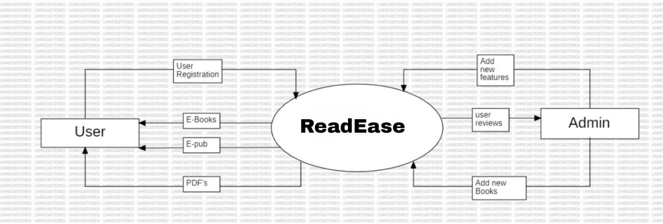

Fig 1 : Illustrate DFD Level - 0

**Class Diagram for ReadEase platform :**

A **class diagram** is a type of static structure diagram in UML (Unified Modeling Language) that describes the structure of a system

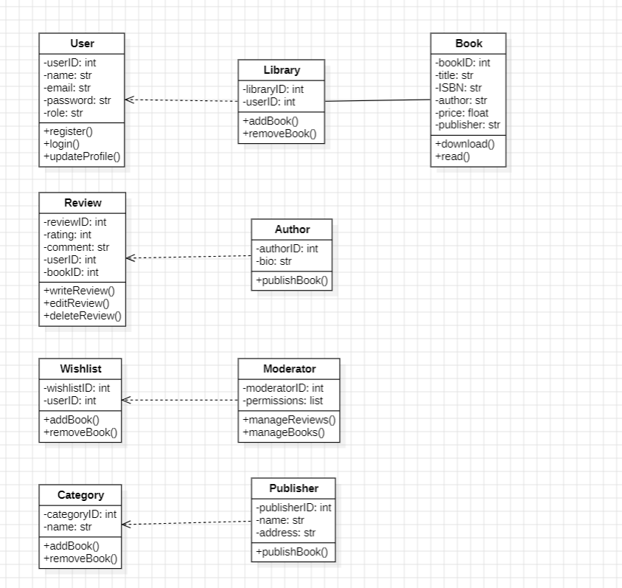

Fig 2 : Illustrate Class Diagram

**Use case diagram for ReadEase Platform :**

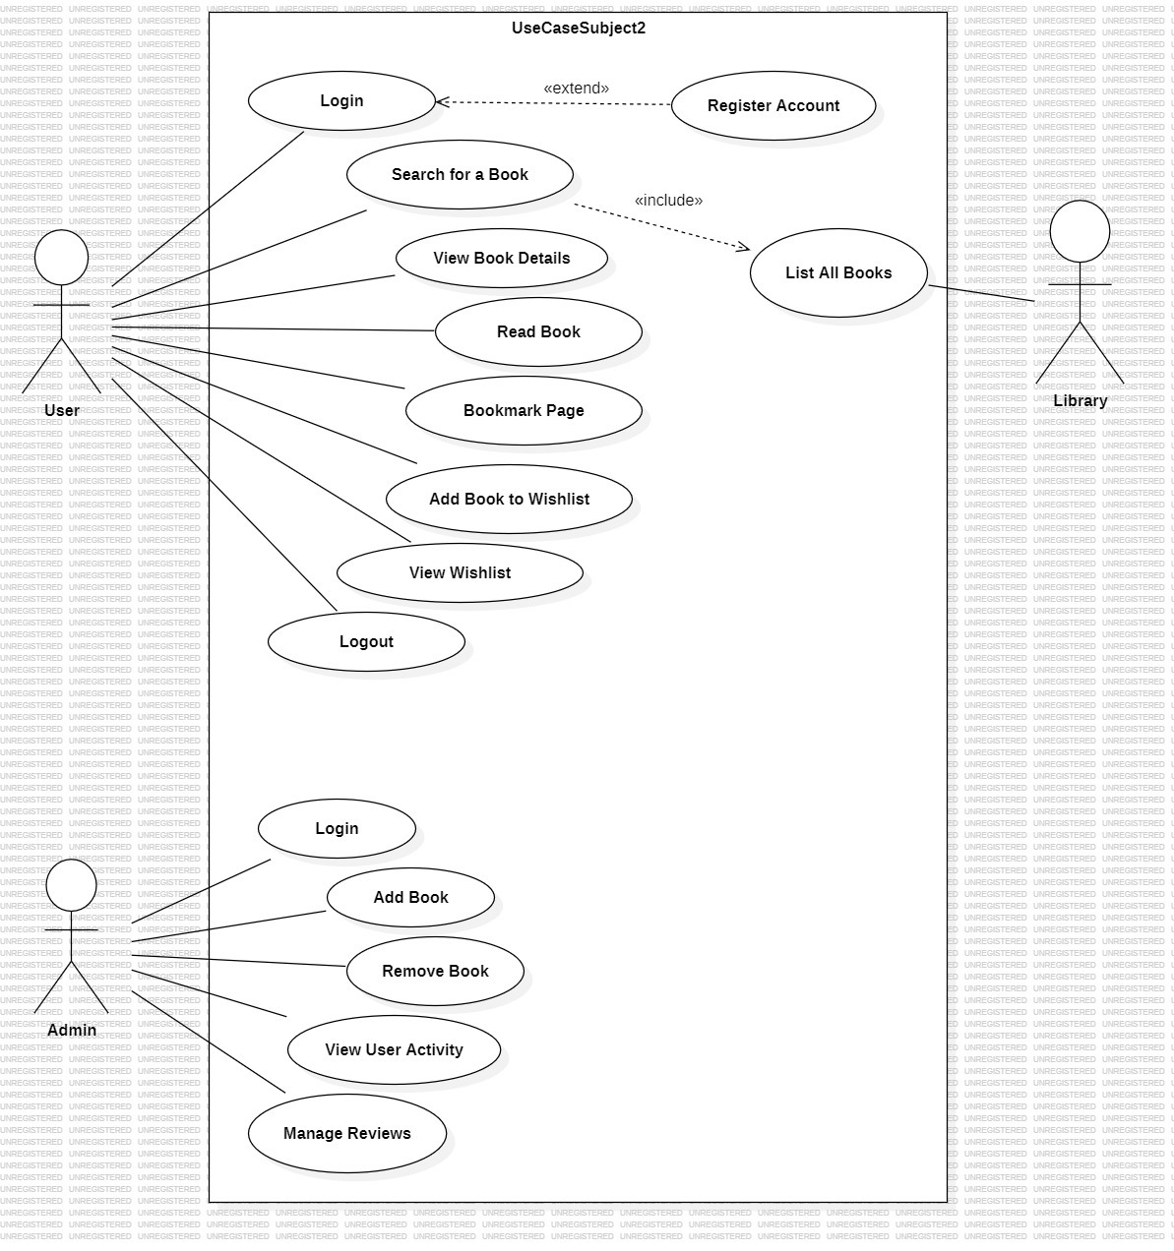A use case diagram is a visual tool that represents how users (actors) interact with a system through specific actions (use cases). It helps clarify system requirements by showing the relationships between actors and use cases, along with the system's boundaries.

Fig 3 : Illustrate Use Case Diagram